1. Where was Timmy?

Unit 3 Focus

**______________________________**

1. According to the story, what did they do

last night?

|  |
| --- |
| Timmy |
| the other students |

1. Let’s prepare for the party!

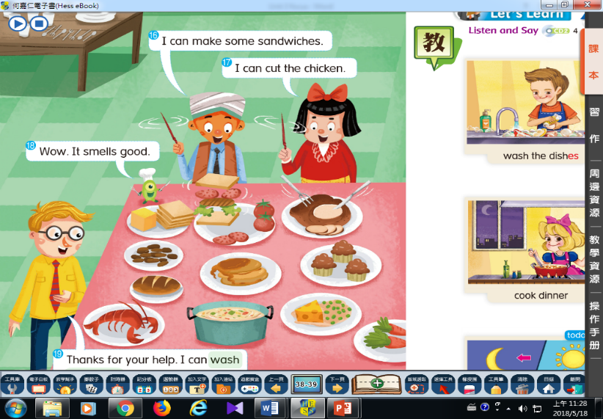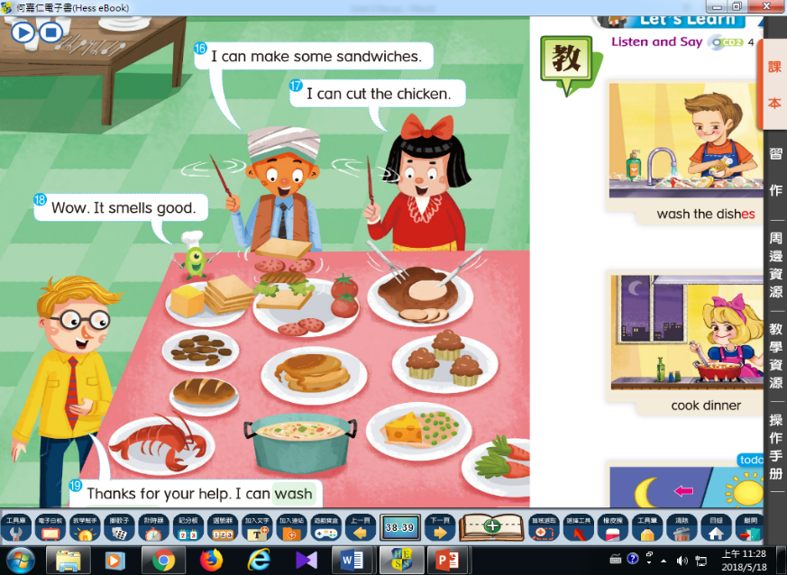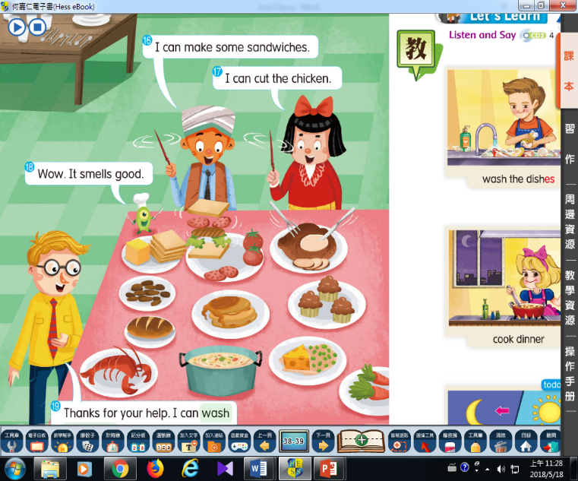

Henry can ________________

David can _________________

Yoko can _________________

1. Where was Timmy?

Unit 3 Focus

**______________________________**

1. According to the story, what did they do

last night?

|  |
| --- |
| Timmy |
| the other students |

1. Let’s prepare for the party!



Henry can ________________

David can _________________

Yoko can _________________